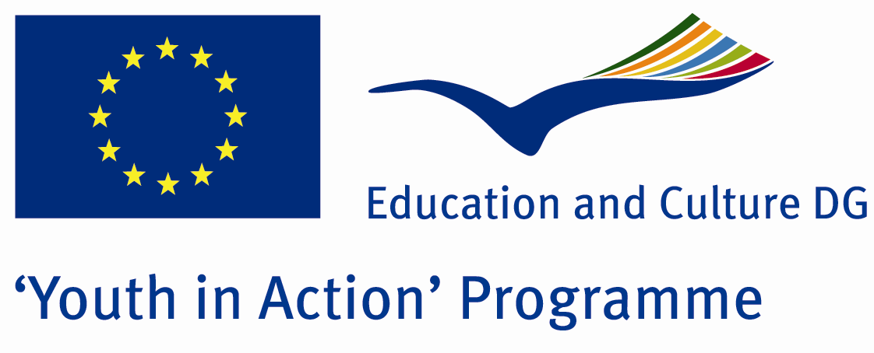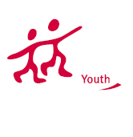

Media of Power



ACTION 4.3 – TRAINING AND NETWORKING

09-15th January, 2012
Duzce, TURKEY

ACTION 4.3 – TRAINING AND NETWORKING
09-15th January, 2012 Duzce, TURKEY

Please contact directly to;
adventurerpeacepigeons@gmail.com

Project Summary;

The media and we are. The media is the most effective weapons in the world. That could destroy a large state or a power take off peak. Big players in an industry-funded incredible. So where do we in this sector? I wonder does the media affect humanity, positive or negative? In every moment of your life in every moment of life must be really wonder if the media do? Did he managed in large financial system?
We have all these questions about the media. You are wondering as much as we do these questions?

Project Title; Media and Us

Date and Venue ; 09-15th January, 2012 Duzce, Turkey.

Target Group ; Municipalities, City Councils and Non-Governmental organizations,
youth groups,culture and art groups,e.t.c

Participants ; 5 people from each country (over 18 -25 ). Totally 8 countries.

Conditions ; Accommodation, board and programme costs will be financed through European Commission Youth in Action Programme (Action 1.1). Travel costs will be reimbursed in 70% (APEX Tarrifs). Organizations from all 27 EU member countries plus Liechtenstein , Norway and Iceland are eligible to take part.

Working language: English

Organizer; Discovery And Adventure Group

How to apply: : If you are interested, please send your Part III forms to
by e-mail please (in word file). Scan Part3 format is enough for application.(Fulfilled Part III which you can find in the attachment, of course signed and stamped) ..

Next step 2;
Original send via regular post to this address please:
Ertan DERİN
Fevzi Çakmak Mahallesi Tuncer Sokak No:6 PENDİK/İSTANBUL/TÜRKİYE
e-mail : adventurerpeacepigeons@gmail.com
Mobile : 0090 542 393 93 90

If you have any questions you may contact with: adventurerpeacepigeons@gmail.com

Deadline: 15th May 2011

For Further information:
Contact Person
Ertan DERİN
Fevzi Çakmak Mahallesi Tuncer Sokak No:6 PENDİK/İSTANBUL/TÜRKİYE
e-mail : adventurerpeacepigeons@gmail.com
Mobile : 0090 542 393 93 90

